Step 1

1. Remove “Direction of Construction.”
2. Project Scope: The order is: New Construction, Rehabilitation, Widening.

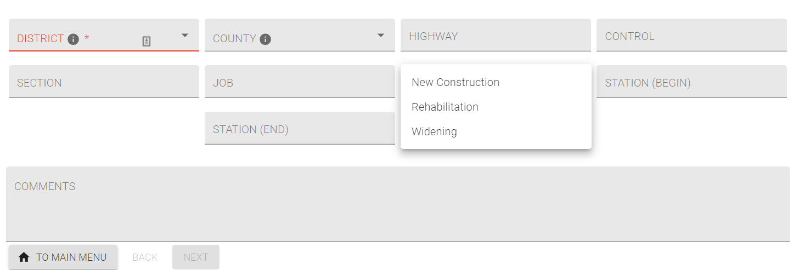

Step 2

1. Remove slide bars for all.

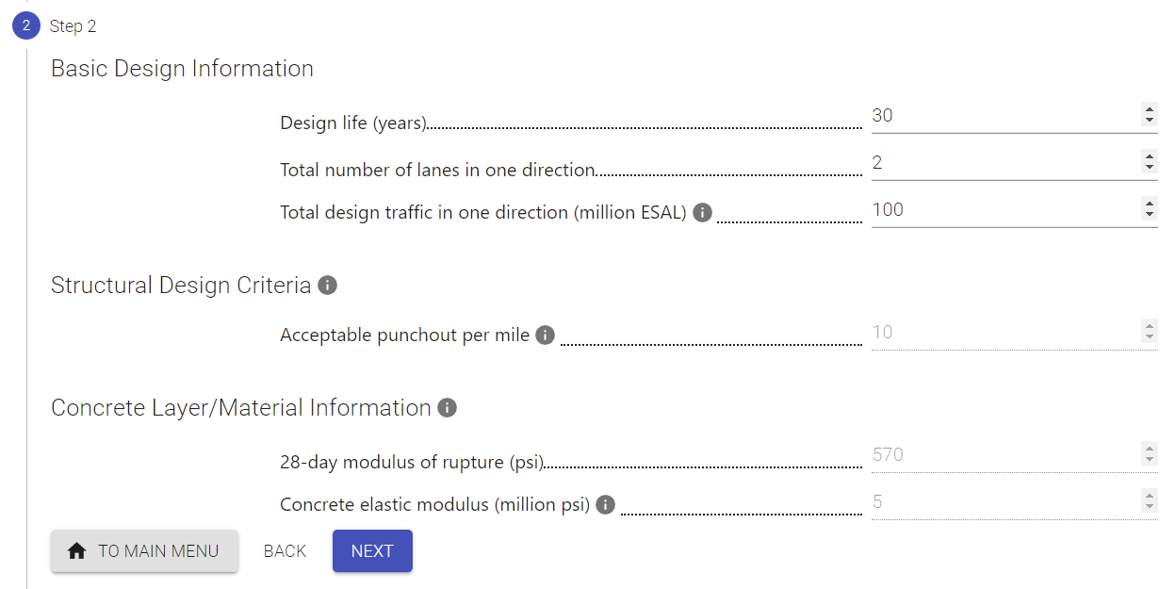

Step 3

1. Subgrade treatment: Lime treated subgrade, Cement treated subgrade, Select fill, No treatment
2. Base Layer Information (first letters capitalized)

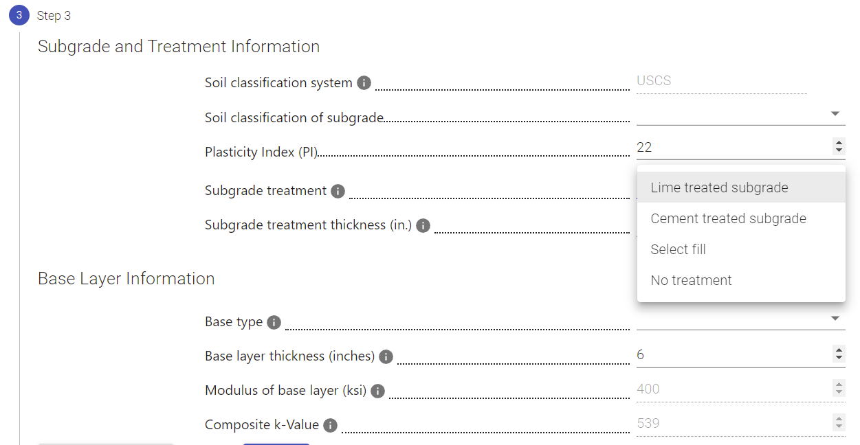

1. HMA (under Base type)

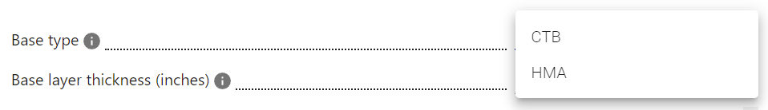

Result

1. Remove “Item 276 Class L.”
2. For HMA base, please make the area darker.

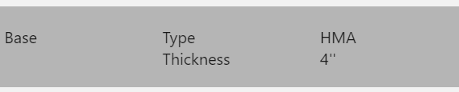

1. Would like to have the output print in one page.

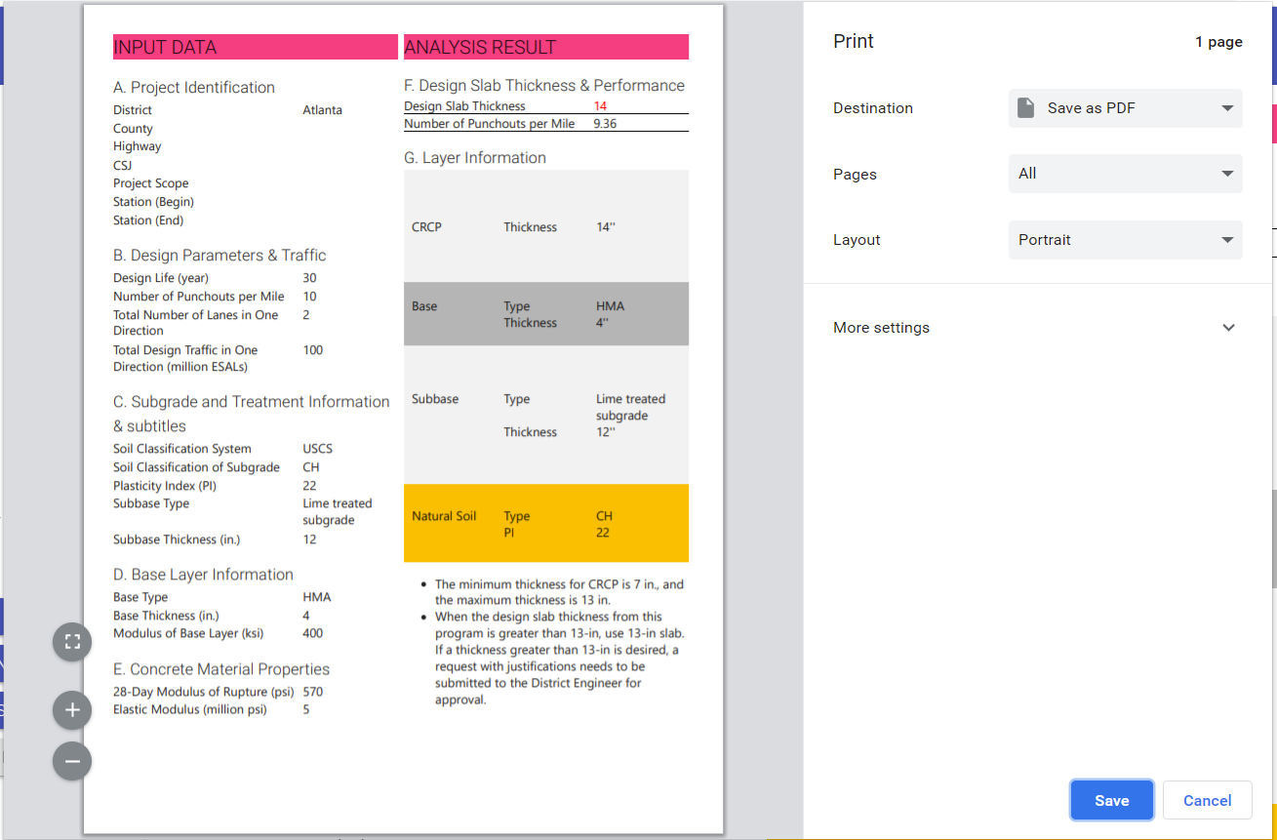

1. Under D, remove “Composite k.”

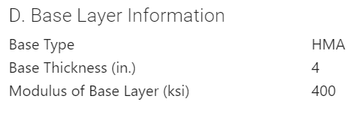

1. Remove “ in front of “The minimum thickness for CRCP is …..”
2. Combine the last two bullets into the following: When the design slab thickness from this program is greater than 13-in, use 13-in slab. If a thickness greater than 13-in is desired, a request with justifications needs to be submitted to the District Engineer for approval.

